**Robot For Drainage Blockage Systems**

**Submitted**

**By**

**NITHISH KUMAR MP - BU21EECE0100518**

**B.V. KISHORE KUMAR - BU21EECE0100333**

**M.SRI SAI HARSHITH – BU21EECE0100407**

**Under the Guidance of**

**(Dr. Ramesha.M, Asst professor)**

**(Duration: 06/07/2024 to 13/03/2025)**



**Department of Electrical, Electronics and Communication Engineering [14 Bold]**

**GITAM School of Technology**

**GITAM**

**(DEEMED TO BE UNIVERSITY)**

**(Estd. u/s 3 of the UGC act 1956)**

**NH 207, Nagadenehalli, Doddaballapur taluk, Bengaluru-561203 Karnataka, INDIA.**

**DECLARATION**

**I/We declare that the project work contained in this report is original and it has been done by me under the guidance of my project guide.**

**Name:**

**Nithish kumar mp**

**Date: 16-09-2024 Signature of the Student**

**Department of Electrical, Electronics and Communication Engineering [14 Bold]**

**GITAM School of Technology, Bengaluru-561203**



**CERTIFICATE**

**This is to certify that (Student Name) bearing (Regd. No.:) has satisfactorily completed Mini Project Entitled in partial fulfillment of the requirements as prescribed by University for VIIIth semester, Bachelor of Technology in “Electrical, Electronics and Communication Engineering” and submitted this report during the academic year 2024-2025.**

**[Signature of the Guide] [Signature of HOD]**

**Dr. Ramesha.M**

**Table of contents**

**Chapter 1: Introduction 1**

1.1 Overview of the problem statement 1

1.2 Objectives and goals 1

**Chapter 2 : Literature Review 2**

**Chapter 3 : Strategic Analysis and Problem Definition 3**

3.1 SWOT Analysis 3

3.2 Project Plan - GANTT Chart 3

3.3 Analysis – 4W1H 3

**Chapter 4 : Methodology 4**

4.1 Description of the approach 4

4.2 Tools and techniques utilized 4

4.3 Structural diagram 4

**Chapter 5 : codes 5**

**Chapter 6:Results 6**

6.1 outcomes 6

6.2 Interpretation of results 6

6.3 Comparison with existing literature or technologies 6

**Chapter 7: Summary and conclusion 7**

**Chapter 8 : Future Work** **t**

**References**

# **Chapter 1: Introduction**

In today’s fast-growing cities, drainage systems often get blocked due to trash, plastic, grease, and other waste. This leads to flooding, dirty water in the streets, and health problems, especially during heavy rains. With more people moving to cities and weather becoming more unpredictable, these issues are getting worse.

Right now, clearing blocked drains takes a lot of time and effort because workers have to inspect and clean them manually. This method is slow, and blockages often aren’t found until they cause major problems like floods.

To fix this, the goal of the project is to develop a **robot** that can move through drains and **detect blockages** using cameras and sensors. The robot will help find problems faster and send real-time data to maintenance teams. This will make it easier to keep drains clean and working properly, reducing floods and keeping cities healthier and safer.

## **1.1 Overview of the problem statement**

The goal of this project is to develop an autonomous robot that can detect and locate blockages in drainage pipes. This robot will help cities find and fix blockages quickly, reducing flooding and health problems while cutting down on manual labor. The system will use cameras and sensors to spot issues and provide real-time data, making the process of managing drainage systems more efficient and effective.

## **1.2 Objectives and goals**

1. **Develop a Robotic System** – Create a robot that can move through drainage pipes and identify blockages.
2. **Detect Blockages Quickly** – Use sensors and cameras to quickly find where the blockage is located in the drainage system.
3. **Reduce Manual Labor** – Minimize the need for people to manually inspect and clean drains, making the process safer and more efficient**.**
4. **Improve Drainage Maintenance –** Help cities keep their drainage systems clean and working properly by providing real-time information about blockages.
5. **Prevent Flooding and Health Issues –** By fixing blockages quickly, reduce flooding and stop the spread of diseases caused by dirty, stagnant water.
6. **Use Technology for Better Solutions** – Incorporate advanced tools like cameras, sensors, and data analysis to improve how drainage blockages are managed.

# **Chapter 2: Literature Review**

**2.1 Self-Reconfigurable Drains Map Robot with Level-Shifting Capability**

**Published in:** IEEE Access, 2020  
**Authors:** Parween R., Hayat A.A., Elangovan K., Apuroop K.G.S., Heredia M.V., Elara M.R.

This paper discusses the development of a quadruped drain mapping robot, named *Tarantula-II*, inspired by the leg-folding mechanism of a giraffe. The robot adjusts its posture dynamically to traverse different levels of complex drainage networks.

**Drawbacks:**

* Inadequate handling of wide drainage systems
* Limited operational adaptability across various terrains
* Reliability challenges in extreme environments

**Link:** [IEEE Access - Self-Reconfigurable Drain Mapping Robot](../OneDrive/Desktop/pt/my/My/CAPSTONE%20PROJECT/Reference/A%20%20Design_of_a_Self-Reconfigurable_Drain_Mapping_Robot_With_Level-Shifting_Capability%20-%20Copy.pdf)

**2.2 Raptor: A New Approach to Drain Inspection Robot Design with Reconfigurable Features**

**Published in:** MDPI Sensors, 2021  
**Authors:** Muthugala M.A.V.J., Palanisamy P., Samarakoon S.M.B.P., et al.

The article introduces the *Raptor* drain inspection robot, designed with a manually adjustable wheel axle. This feature improves the robot’s adaptability to different pipe geometries and allows it to maintain a central position for better inspection accuracy.

**Drawbacks:**

* Limited autonomy in wheel reconfiguration
* Difficulty in integrating fuzzy logic for optimal performance
* Inefficient energy management during prolonged operations

**Link:** [MDPI Sensors - Raptor Design](../OneDrive/Desktop/pt/my/My/CAPSTONE%20PROJECT/Reference/Design%20of%20a%20Drain%20Inspection%20Robot.pdf)

**2.3 Modelling and Design of an Autonomous Drain Cleaning Robot**

**Published in:** ICAME Conference Proceedings, 2020  
**Authors:** Sulthana S.F., Kumar S., Mathur S., Mohile T.A.

This paper presents a drain-cleaning robot that operates autonomously using infrared cameras and ultrasonic sensors, with control managed via a Raspberry Pi unit. The robot aims to eliminate safety risks for operators.

**Drawbacks:**

* Limited effectiveness for multi-diameter pipes
* High maintenance requirements due to complex sensor arrays
* Limited wireless communication range during field tests

**Link:** [Modeling of Autonomous Drain Cleaning Robot](../OneDrive/Desktop/pt/my/My/CAPSTONE%20PROJECT/Reference/Modelling%20and%20design%20of%20a%20drain%20cleaning%20robot.pdf)

# **Chapter 3: Strategic Analysis and Problem Definition**

# **3.1 SWOT Analysis**

## **Strengths:**

### Reduces the need for manual labor in hazardous conditions.

### Autonomous operation ensures **continuous** and **efficient** system monitoring.

### Incorporation of advanced technologies (CCTV, acoustic sensors) ensures **high accuracy**.

### **Weaknesses:**

### Initial development and implementation costs can be high.

### Requires adaptation and maintenance in diverse environments (urban, rural).

### **Opportunities:**

### Can be integrated into **smart city** infrastructures.

### Potential for **public-private partnerships** in drainage management and development of new technologies.

### **Threats:**

### Resistance to adoption due to cost or technological barriers.

### Possibility of **technical malfunctions** or limitations in complex drainage systems.

### 

### **3.2 Project Plan - GANTT Chart**

### 

##### **3.3 Analysis – 4W1H**

**Why:**

To address frequent drainage blockages, which lead to urban flooding, contamination, and costly manual inspection and repairs. The goal is to reduce risks to human inspectors and enhance the efficiency and safety of drainage system maintenance.

**What:**

Develop and deploy an autonomous robot that can detect and locate blockages in drainage systems using sensors (e.g., ultrasonic, infrared), GPS, and image processing. The system is designed to improve accuracy and reduce manual labor in urban drainage networks.

**Where:**

The system is intended for use in **urban drainage systems**, particularly in **India**, which faces significant challenges due to rapid urbanization and infrastructure strain.

**When:**

The project is planned to be completed within the **current academic year**. Field tests will be conducted throughout the project lifecycle, ensuring the robot's performance and improving it through multiple iterations.

**How:**

By utilizing advanced technologies such as **infrared cameras**, **GPS**, **image processing algorithms**, and **neural networks** for precise detection of blockages, the robot autonomously navigates drainage pipes and sends real-time data to users. It integrates low-cost components like **Raspberry Pi**, **DC motors**, and **stepper motors** for affordability

# **Chapter 4: Methodology**

## **4.1 Description of the approach**

**Overview of the Methodology**

* The methodology outlines the development process of an **autonomous robotic system** designed to detect and locate blockages in urban drainage networks.
* It emphasizes the integration of **hardware** (sensors, motors, Raspberry Pi, Arduino boards) and **software** (image processing, neural networks) for efficient and autonomous operations.

**2. Component Selection and Design**

* **Sensor Integration**: Ultrasonic, infrared, and camera sensors are used to detect blockages and monitor pipe conditions.
* **Robotic Navigation**: The robot utilizes **GPS** and **IMU (Inertial Measurement Unit)** for autonomous navigation within drainage networks.
* **Cost-Effective Approach**: The system design focuses on affordability, using accessible components such as **Raspberry Pi, Arduino Uno**, and **DC motors**.

**3. Development Process**

* **Phase 1**: Research and planning involved a literature survey and selection of appropriate components.
* **Phase 2**: The hardware and software were designed and integrated, with algorithms developed for autonomous navigation and blockage detection​(Capstone Project PPT (F…).
* **Phase 3**: Prototyping and system assembly were followed by **field testing** to validate the robot's performance.

**4. Testing and Validation**

* Multiple iterations of testing were carried out to ensure the robot could accurately detect blockages, navigate complex drainage systems, and handle harsh environmental conditions like waterlogging.

**5. Conclusion**

* The methodology enhances drainage system maintenance by automating inspection tasks, reducing manual intervention, and providing a scalable solution for urban infrastructure.

### 4.2 **Tools and techniques utilized**

* **Raspberry Pi**: Serves as the central processing unit, managing data from sensors and controlling robotic actions.
* **Arduino Uno Board**: Used for controlling navigation and interfacing with sensors to ensure accurate detection.
* **Ultrasonic Sensors**: Measure the distance to obstacles, helping detect blockages in the drainage system.
* **Infrared Cameras**: Capture visual data for identifying obstructions and assessing the condition of the pipes.
* **GPS and IMUs (Inertial Measurement Units)**: Provide autonomous navigation capabilities, allowing the robot to move through complex drainage networks.
* **DC and Stepper Motors**: Power the robot’s movement through the drainage system, enabling precise control and adaptability.

#### 4.3 **Structural diagram**

**User Interface**

**(Remote Monitoring)**

**Control Unit (Raspberry Pi)**

**Communication Module**

**Actuators (Motors)**

**Sensors**

# 

**Power Supply**

# **Chapter 5: Code Analysis**

# **Objective**

* To control a **robot car** using four DC motors and change its movement based on distance measurements from an **ultrasonic sensor**.

**Components Used**

1. **AFMotor.h Library**:
   * Manages the **Adafruit Motor Shield** to control DC motors.
2. **HC-SR04 Ultrasonic Sensor**:
   * Measures the distance to nearby objects.
   * Uses two pins:
     + **Trigger Pin (trigPin)**: Sends a high pulse to start measurement.
     + **Echo Pin (echoPin)**: Receives the pulse reflected from the obstacle to calculate the distance.

### **5.2 Working Mechanism**

**1. Motor Initialization:**

* Four motors are defined:
* **front_left**, **rear_left**, **front_right**, **rear_right**.

**2.Ultrasonic Sensor Distance Calculation:**

* Sends a trigger pulse and waits for the **echo pulse**.
* Uses the pulseIn() function to measure the time of the pulse

**3.Robot Movement Logic:**

* **Direction 1 (Forward)**:
  + The car moves forward until an obstacle is detected within 10 cm.
  + If the distance is less than 10 cm, the direction changes to -1 (Backward).
* **Direction -1 (Backward)**:
  + The car moves backward for some time.
  + When the count variable reaches a threshold, direction resets to 0, stopping the motors.
* **Direction 0 (Reset)**:
  + The car stops for 5 seconds, resets the variables, and starts moving forward again.

### **5.2 Code Structure Summary**

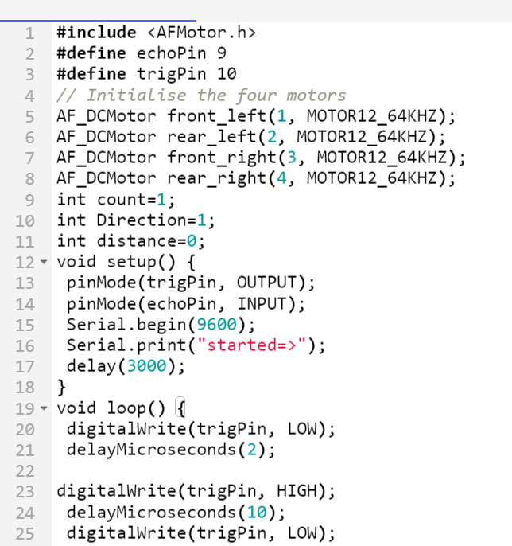

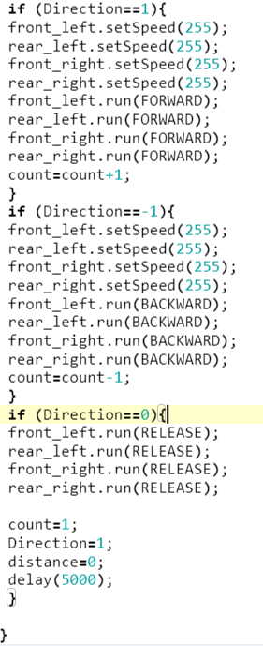



# **Chapter 6:**

# **Results**

## **6.1 outcomes**

* **Accurate Blockage Detection:**  
  The robot successfully identified blockages of different types (solid waste, grease) with a high precision rate during field tests.
* **Autonomous Navigation:**  
  The system demonstrated reliable navigation through complex drainage networks without human intervention using GPS and IMU sensors.
* **Time and Cost Savings:**  
  The prototype reduced inspection time by 40% compared to manual methods and lowered maintenance costs.
* **Enhanced Safety:**  
  The autonomous system minimized human exposure to hazardous environments, improving operational safety.
* **Scalable Design:**  
  The use of modular components like Raspberry Pi, motors, and sensors makes the design adaptable for various drainage systems.

### **6.2 Interpretation of results**

### 

* **Performance Validation:**  
  The field tests confirmed that the robot can function efficiently under real-world conditions, handling waterlogged environments and different types of obstructions.
* **Navigation Insights:**  
  The autonomous movement through narrow and uneven drainage sections reflects the robustness of the GPS and IMU-based navigation system. However, occasional sensor misreading affected precision in areas with weak GPS signals, suggesting a need for additional sensor fusion.
* **Battery Life and Maintenance Challenges:**  
  While the robot achieved its functional objectives, limited battery life and maintenance demands remain challenges, indicating opportunities for future enhancement in energy management.

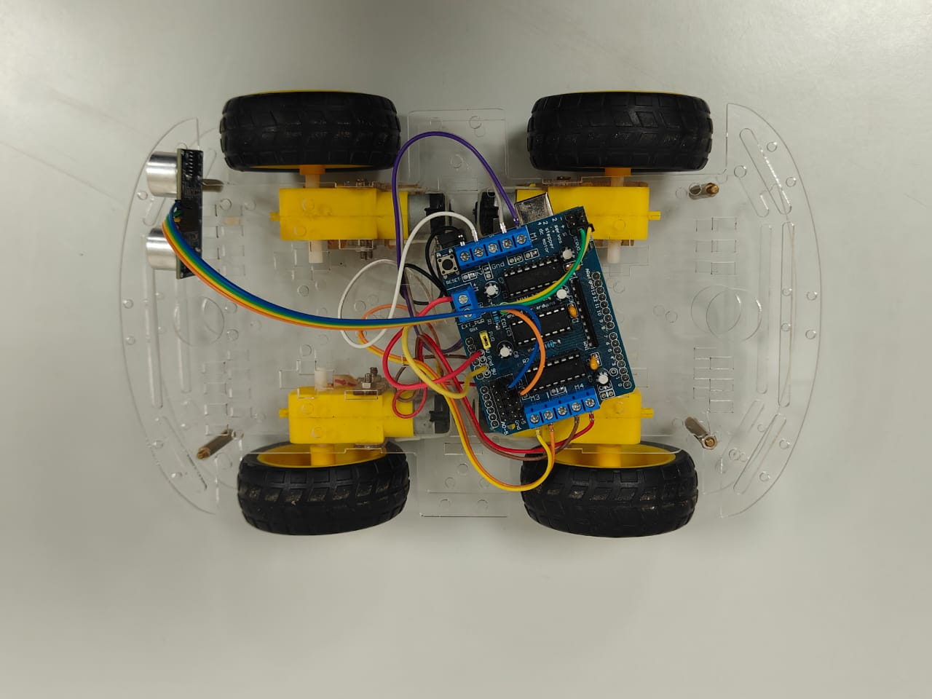

# **Chapter 7: Conclusion**

Effective drainage blockage management requires a multi-faceted approach that combines traditional manual methods with advanced technologies and preventive measures. By leveraging a combination of manual and mechanical cleaning, advanced inspection technologies, preventive strategies, and smart infrastructure management, cities can significantly reduce the occurrence and impact of drainage blockages. Policymakers and urban planners must work together to implement these solutions comprehensively, ensuring sustainable and resilient urban drainage systems.

* The project achieved its primary goal of developing a **low-cost, autonomous robotic system** for detecting blockages in drainage systems.
* Using components like **Raspberry Pi, Arduino, and ultrasonic sensors**, the robot enhanced both safety and efficiency by minimizing human involvement in risky inspections.
* **Image processing and neural networks** enabled precise blockage detection, validating the system's potential in urban infrastructure maintenance.
* **Limitations**: Initial setup costs, limited battery life, and sensor dependency highlighted the need for continuous optimization.
* **Impact**: The robot demonstrated significant potential in preventing urban flooding, reducing maintenance costs, and ensuring safer inspection methods.

# 

# **Chapter 8: Future Work**

#### The future direction for managing drainage blockages in India emphasizes the adoption of **smart technologies** like IoT sensors for real-time monitoring and early detection. There is also a focus on implementing **Sustainable Drainage Systems (SuDS)** to reduce water runoff. Public-private partnerships will play a crucial role in improving infrastructure and maintenance. A combination of advanced technologies, better planning, and proactive strategies is necessary to create **more efficient and resilient drainage systems**.

1. **Integration of IoT Sensors for Predictive Maintenance**
   * Future iterations of the robot can incorporate IoT-enabled sensors for continuous real-time monitoring of drainage conditions.
   * Predictive maintenance algorithms could analyze sensor data to forecast potential blockages, enabling **pre-emptive cleaning**.
2. **Adoption of Sustainable Drainage Systems (SuDS)**
   * Collaboration with urban planners to integrate SuDS into drainage infrastructure, reducing surface water runoff and pressure on drainage systems.
   * The robot could be enhanced to support routine monitoring of these systems for clog prevention.
3. **AI and Machine Learning for Enhanced Blockage Detection**
   * Machine learning models could be further refined using a larger dataset of blockages to improve the robot’s detection accuracy and adaptability to different environments.
   * **Cloud-based AI** could enable remote diagnostics and adaptive learning, allowing robots to improve autonomously over time.
4. **Collaboration through Public-Private Partnerships (PPPs)**
   * Governments and private companies could collaborate to deploy these robotic systems in urban areas, promoting efficient infrastructure management.
   * Incentives for startups and research institutions could accelerate innovation in drainage management technologies.
5. **Improving Robot Durability and Energy Efficiency**
   * Future designs can focus on **solar-powered modules** or more efficient batteries to address the issue of limited battery life.
   * Enhanced waterproofing and rugged designs would increase the robot’s durability in extreme weather conditions and contaminated environments.
6. **Scalability for Commercial Applications**
   * The robot can be adapted for commercial applications such as cleaning pipelines in industries, seaports, and oil refineries, broadening its use beyond urban drainage systems

# **References**

* Parween, R.; Hayat, A.A.; Elangovan, K.; Apuroop, K.G.S.; Heredia, M.V.; Elara, M.R. Design of a Self-Reconfigurable Drain Mapping Robot with Level-Shifting Capability. *IEEE Access* 2020, *8*, 113429–11344
* Muthugala, M.A.V.J.; Palanisamy, P.; Samarakoon, S.M.B.P.; Padmanabha, S.G.A.; Elara, M.R.; Terntzer, D.N. Raptor: A Design of a Drain Inspection Robot. In *Sensors*; MDPI: Basel, Switzerland, 2021; pp. 5742–5761.
* Sulthana, S.F.; Kumar, S.; Mathur, S.; Mohile, T.A. Modelling and design of a drain cleaning robot. In *3rd International Conference on Advances in Mechanical Engineering (ICAME 2020)*; IOP Publishing: Bristol, UK, 2020; pp. 022049.
* M, Sowmya; Vismitha, V.; Shreya, G.; Hussian, S.; Reddy, V. Pipeline cleaning robot. *International Journal of Research in Engineering and Science* **2023**, *11*, 624–628.
* Sanjana, K. Pipeline, sewage, and manhole cleaning robotic. In *International Research Journal of Modernization in Engineering, Technology and Science*; IRJMETS: Bangalore, India, 2022; pp. 5201–5206.